***UI Appendix:***

**Date: 29/09/2023**

**Mode of Interview: Physical**

The user interface design outlines created for each page of the application were shown to the client for his feedback and approval before commencement of the development process.

***SignIn Page – Design Outline***

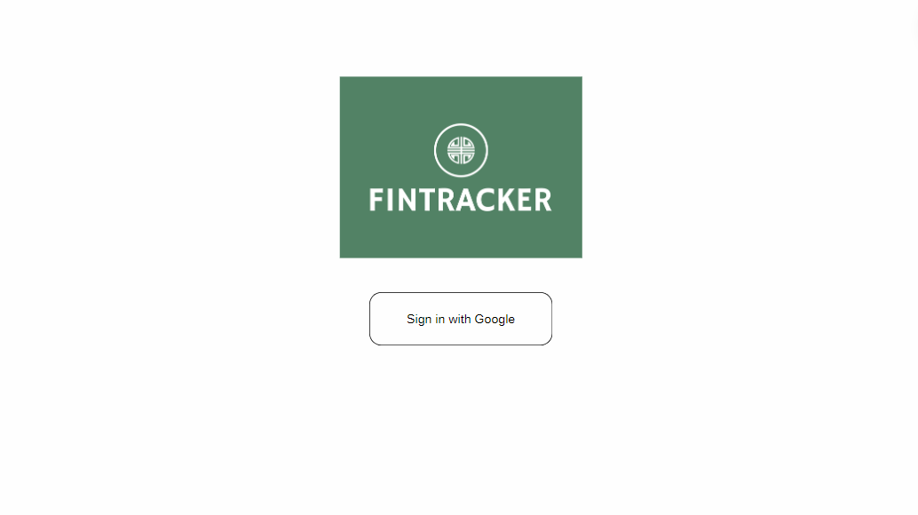

Sign in button

***Home Page – Design Outline***

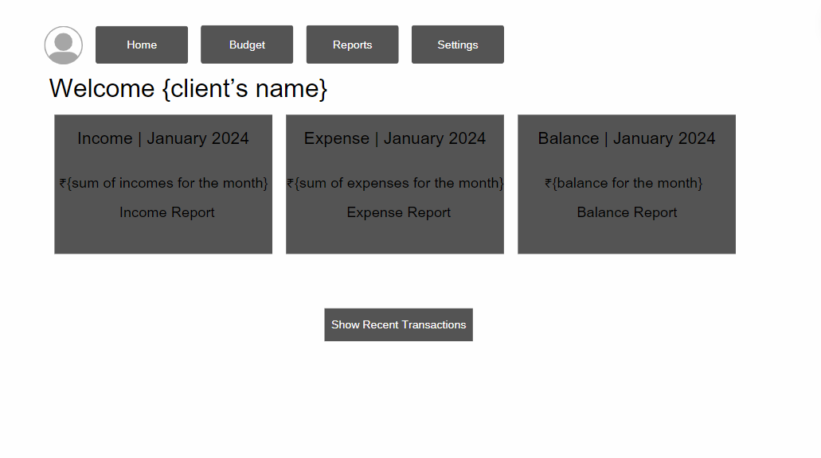

Button to display recently made transactions

***Budget Page – Design Outline***

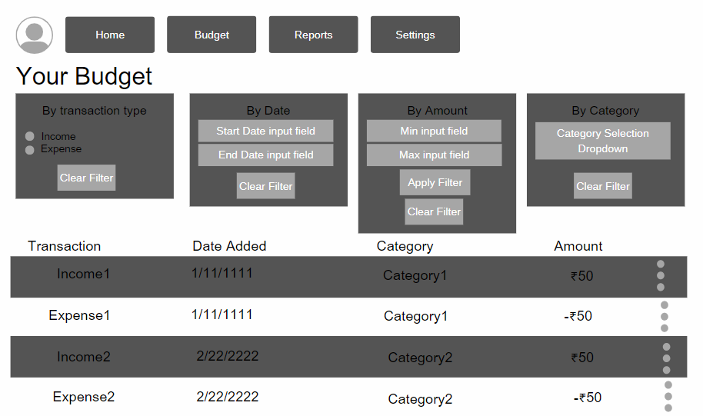

Filter by income/expenses

Filter by transaction date added

Filter by transaction amount

Filter by transaction category

***Reports Page – Design Outline***

Page Design – 1

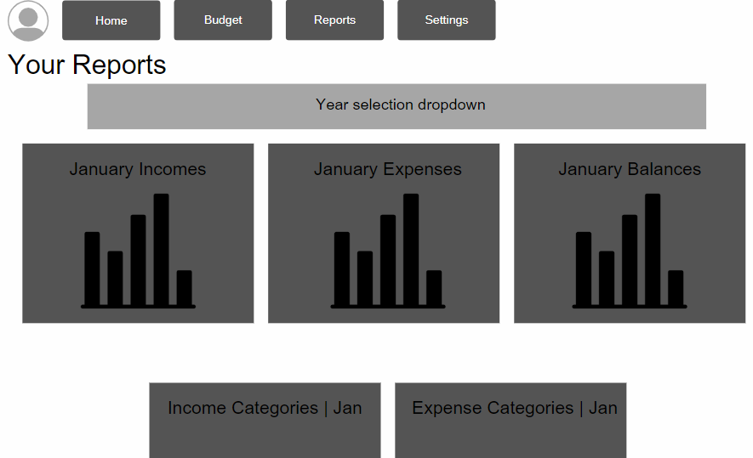

Year selector whichallows for filtering transactions by year added

Month selectors which allow for filtering transactions by month added

Page Design – 2

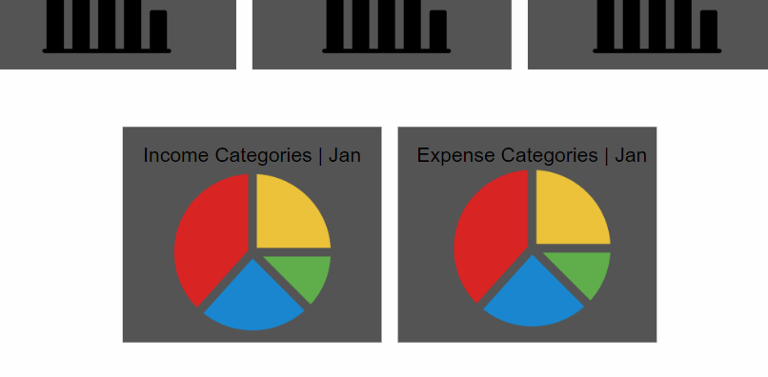

Month selectors which allow for filtering transactions by month added

***Settings Page – Design Outline***

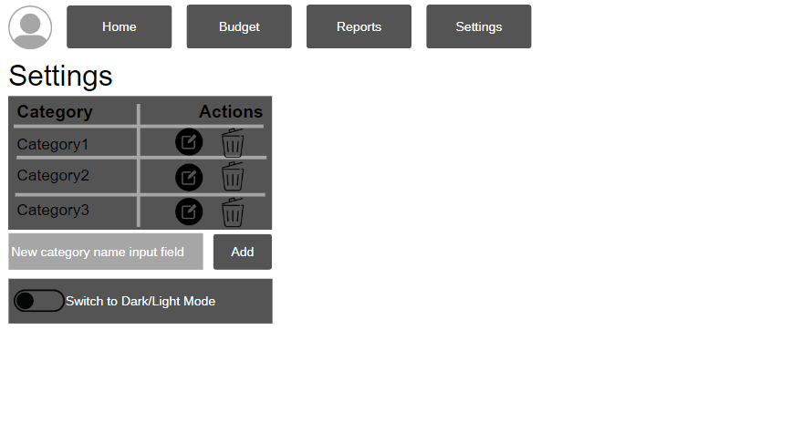

Button for editing a category’s name

Button to delete a category

Button to create a new category

***Client’s Signature of Approval***

